|  |  |
| --- | --- |
| TEAM ID | **PNT2022TMID53615** |
| PROJECT NAME | **SMART SOLUTION FOR RAILWAYS** |

# PROJECT DEVELOPMENT DELIVERY OF SPRINT-2

**SPRINT-2**

STEPS TO BE DONE :

1. Creating form to collect details
2. Seat selection
3. Selecting Boarding and Destination
4. Submitting and checking in debugger

# NODE-RED DESIGN

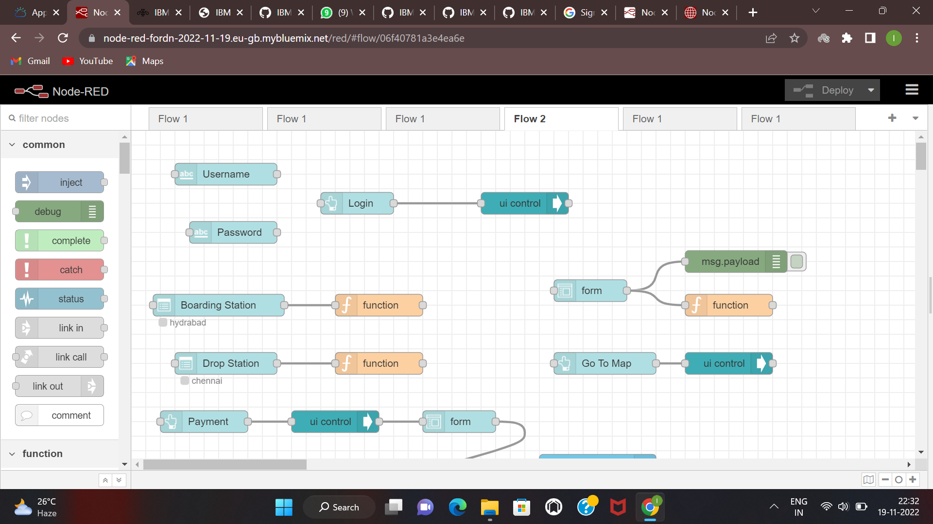

**BOOKING IN WEB PAGE**

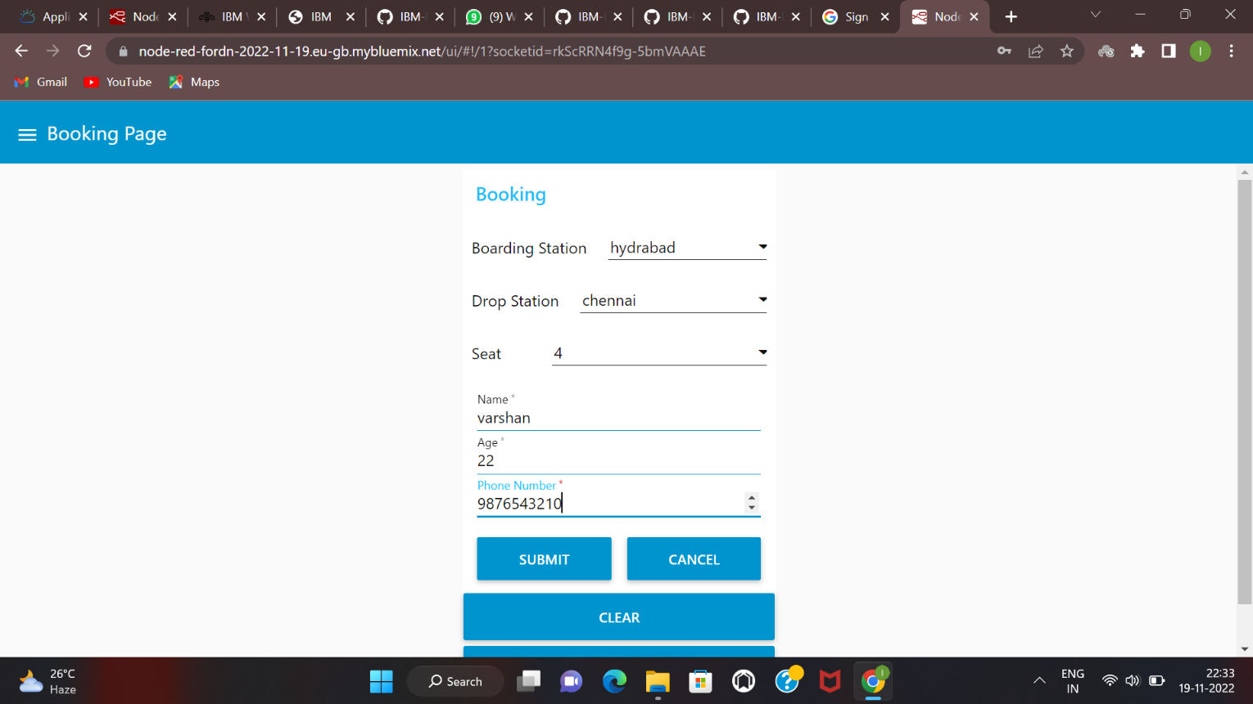

# CHECKING IN DEBUGGER

